

Sunrise Presbyterian Church
Ninth Sunday of Easter
Sunday, May 31st, 2026 at 9:30 a.m.
Rev. Jessica Crane Munoz

*Please rise in body/spirit as you are able.
Announcements |  | Jessica
🎹 Prelude | O Master Let Me Walk with You  arr. Cindy Berry | Kim Peachy
Call to Worship: |  | Jessica
Leader: From many roads and many places, we have arrived at this hour of worship.
All: We come as travelers who have experienced weariness and wonder.
Leader: As once the risen Christ drew near to disciples on the way to Emmaus, so he draws near to us.
All: Open our eyes, O Lord. Make your presence known to us, just as you have revealed yourself to pilgrims in every age.

*♫Hymn # 667 | When Morning Gilds the Skies |  |  |  | vs. 1-3
* Call to Confession |  |  |  | Liturgist: Pam Chigbrow
God is present to guide our journey and eager to forgive us when we go astray; therefore, in humility and faith, let us confess our sins against God and neighbor.
*🙏Prayer of Confession (in unison): |  |  | Liturgist
O Lord who calls and sends, we confess that we have not always answered with alacrity or with grace. There are roads to which you have summoned us that we have been slow to travel – roads that seemed to us inconvenient or unworthy of our gifts, roads that led toward people or places we would not have chosen on our own.
We have offered you our preferences when you asked for our obedience, and our hesitations when you called for our trust. Forgive us, gracious God, for the callings delayed and the sending resisted. Amen.
*Assurance of Pardon |  |  | Liturgist
Leader: Take heart in this good news. Our God redeems imperfect obedience and works through halting faithfulness. In Jesus Christ, we are forgiven and renewed for the journey.
All: Thanks be to God!
*♫Gloria Patri
Glory be the Father, and to the Son, and to the Holy Ghose. As it was in the beginning, is now and ever shall be. World without end. Amen. Amen.
*Passing of the Peace Liturgist
Leader: May the peace of our Lord Jesus Christ be with you.
All: And also with you.

🙏Prayer of Illumination (non-responsive, please be seated) |  |  |  |  | Liturgist
Holy God. as we receive your word now, remind us that it goes before us on every road we are called to travel. Open us to your Spirit, that we may be equipped for whatever way lays ahead. Speak, Lord, for your servants are listening. Amen.
& Scripture |  | Acts 9:1-9 |  |  | Liturgist
Children’s Message |  |  | When 2 or more are present
*♫Hymn # 409 | God is Here! |  |  | vs. 1,2,4
& Scripture |  | Acts 9:10-22 |  |  | Pastor Jessica
Message |  |  |  |  | Pastor Jessica
Invitation to Offering |  |  |  |  | Liturgist
All that we have, and all that we are, comes from God. We are invited by God to share our God-given gifts, so that all may know Jesus’ loving and saving power.
Offering trays are not passed in the sanctuary. However, we recognize the importance of blessings and giving through the offertory portion of our service.  If you wish to make a financial gift, an offering tray is located at the entrance to the sanctuary. Financial gifts may also be made through the church website. |  |  |  |  |  | 
🎹 Offertory Music Poor Wayfaring Stranger  arr. Joseph M. Martin |  |  |  |  | Kim Peachy
*♫Doxology
Praise God from whom all blessings flow. Praise God all creatures here below. Praise God above ye heavenly host. Praise Father, Son, and Holy Ghost. Amen.
*🙏 Prayer of Thanksgiving/Offertory Prayer: (unison) |  |  | Liturgist
Sending God, you have never asked us to go empty-handed, nor have you allowed those sent in your name to travel without your presence. We bring these offerings now as an act of participation in your mission – the resources of a people who have themselves been sent, given in trust that you will deploy them where they are most needed. Receive them to your glory and the service of your kingdom. Amen.
*♫Hymn # 468 In My Life

Sharing of Joys and Concerns
🙏 Prayer of Intercession: (responsive) | Liturgist
Leader: Shepherd God, who gathers us for worship and prayer, who sustains us with the breath of life, who quenches our thirst with calm and holy waters, hear our prayers for those in need.
All: Grant relief to the suffering, have mercy on the oppressed, heal the sick, raise up those who have been beaten down, feed the hungry, humble the proud, return the lost, release the captives, revive those who are exhausted and weak, calm the anxious, comfort those who live in fear, redeem our violent, warring world, grant us all peace.
Leader: Ground us in your good news, O God, and help us hold on to your promises of hope. Keep our feet steady on Christ’s path as we seek to be his faithful followers, praying the prayer Jesus taught us, saying:
The Lord’s Prayer: Our Father, who art in heaven. Hallowed be thy name. Thy kingdom come; thy will be done. On earth, as it is in heaven. Give us this day our daily bread. And forgive us our debts as we forgive our debtors. And lead us not into temptation but deliver us from evil. For thine is the kingdom, and the power and the glory forever. Amen.

*♫Hymn # 721 | Lord, You Have Come to the Lakeshore |  | vs.1,2,4
Sending Out God’s People into the World
*Benediction
🎹 Postlude (seated)  👏 |  | I Want Jesus to Walk With Me  arr. Mary McDonald |  | Kim Peachy
*Please rise in body/spirit as you are able.
Sunrise Presbyterian Church
sunrisepresbyteriangf@gmail.com
www.sunrisegreatfalls.net
406-453-2031 or Pastor Jessica cell: 908-300-4286
Office Hours: 8:30-12:30 Monday-Thursday

Symbols within the bulletin are to assist folks attending our worship service who respond better to social cues when they are visualized. We want everyone to feel comfortable and confident when they attend worship. 🙏 = prayer, 🎹 = music to listen to, ♫ = music to sing to, & = scripture or textual reading, 🕈 = celebration of a sacrament,👏 = clapping is appropriate. Bold text indicates places for congregational participation.

We have someone signed up to host fellowship through June 7th, however after that we have no one. The clipboard for Sunrise Fellowship will be coming through the congregation. Please, if you can, sign up to host a fellowship in the coming months.

We have added a whiteboard to the wall outside of the office. This is for parents/families to mark dates/times to alert those interested in attending events. This provides an opportunity to demonstrate our interest in what these young lives are doing – not intended to attend every activity or as a group, but to pick and choose what works within our individual schedule.




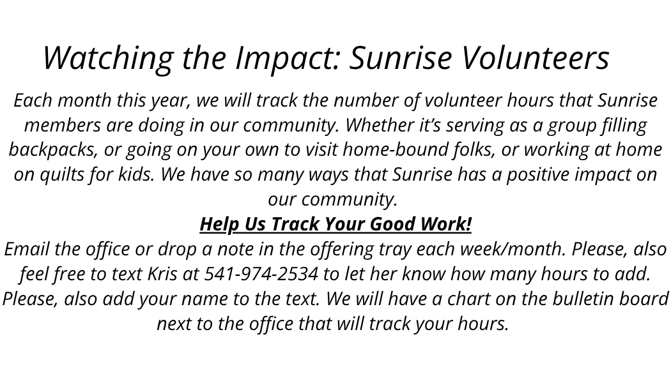
Calendar of Events
May Deacons: Tana Harp & Sandy Lambert
May 31 | Sun | 9:30 am | Worship
 |  |  | Sidewalk Dedication Directly After Worship
 |  | 10:30 am | Fellowship
June Deacons: Janette Forsyth & Beth Hoseck
6/1 Thru 7/6 Product Exchange: Table in the narthex
June 3 | Wed | 6:00 pm | Worship Committee
June 5 | Fri | All Day | Last Day of School for GFPS
June 7 | Sun | 9:30 am | Worship
 |  | 10:30 am | Fellowship
June 8 | Mon | All Day | Joe will be picking up crayons from local Schools
June 14 | Sun | 9:00 am | Worship with Communion
 |  | 10:30 am | Fellowship; Crayon Sorting
June 15 | Mon | All Day | Newsletter Items Due
June 17 | Wed | 6:00 pm | Faith-Life, Outreach, Mission Meeting
June 19-20 | Fri/Sat | All Day | Presbytery Meeting in Hamilton MT
June 21 | Sun | 9:30 am | Worship
 |  | 10:30 am | Fellowship; Crayon Sorting & Happy Fathers Day
June 21-26 | Sun/Fri | All Day | Pastor Jessica up at Glacier Camp  Office Open Kris is still here
June 23 | Tue | 5:30 pm | Session
June 24 | Wed | 10:00 am | Newsletter Folding
June 27-July 3 | Sat/Fri | All Day | Jessica will be in Milwaukee General Assembly
June 28 | Sun | 9:30 am | Worship
 |  | 10:30 am | Fellowship

A dedication of our recent sidewalk extension will be held outside on the new sidewalk directly following worship today in memory of Barb Chigbrow. (If it's raining, the dedication will be held in the sanctuary.)

Month | Jan | Feb | Mar | Apr | May
Community Volunteer Hours | 124 | 128.75 | 197.50 | 127.50 | 140.50

