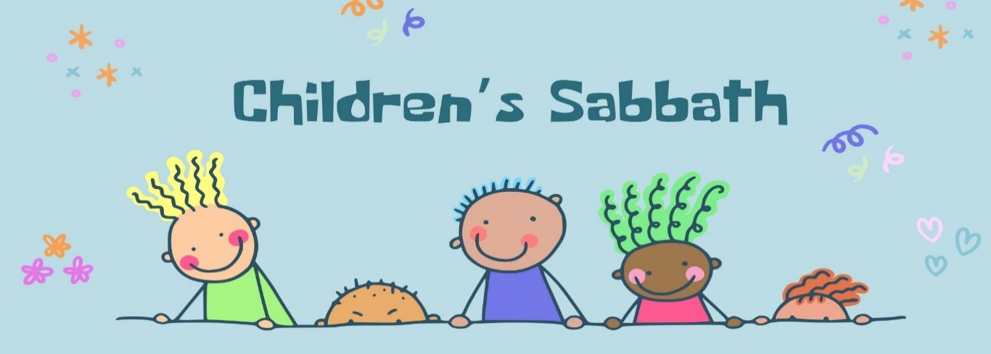

Sunrise Presbyterian Church
Children’s Sabbath & World Communion Sunday (observed)
Sunday, October 11, 2026 at 9:30 a.m.
Rev. Jessica Crane Munoz

*Please rise in body/spirit as you are able.
Announcements |  |  | Pastor Jessica
Introduction
🎹 Prelude |  | Jesus Loves Me | Kim Peachy
 |  | arr. Nancy Lyons Smith
& Proverbs |  | Proverbs 15:1 | Sophie
Call to Worship: |  |  | Pastor Jessica
Leader: | Bless the Lord, O my soul, and all that is within me,
All: | Bless God’s Holy Name.
Leader: | Bless the Lord, O my soul,
All: | Who redeems our life, and who satisfies us with good as long as we live. Bless the Lord!

*♫Hymn # 307 | God of Grace
& Proverbs | Proverbs 3:27  Proverbs 17:17 |  | Grace  Jesse
* Call to Confession |  | Liturgist: Rowena Milton
In sure confidence of God’s forgiveness, let us confess our sins before God and one another.
*🙏Prayer of Confession (in unison): |  | Liturgist
God of grace, love, and communion, we confess that we have failed to love you with all our heart, soul, and mind; and to love our neighbor as ourselves. We ignore your commandments, stray from your way, and follow other gods.
Have mercy on us. Forgive our sins and raise us to new life that we may serve you faithfully and give honor to your holy name.
*Assurance of Pardon |  | Liturgist
God did not send the Son to condemn the world, but in order that the world might be saved through him. In the name of Jesus Christ, we are forgiven. Thanks be to God.

*♫Gloria Patri # 581 – Glory be to the Father. And to the Son. And to the Holy Ghost. As it was in the beginning, is now and ever shall be. World without end; Amen. Amen.
& Proverbs x 2 | Proverbs 6:6 |  | Hannah
 | Proverbs 17:22

🙏Prayer of Illumination |  |  |  | Liturgist
Holy God, as we read your word, may your Spirit speak through it that it may be for us the word of life. Amen.
& Proverbs x 2 | Proverbs 13:20 |  | Sebastian
 | Proverbs 14:29
*♫Hymn # 288 | Spirit of the Living God |  | 2x
& Proverbs x 2 | Proverbs 22:6  Proverbs 27:17 |  | Kierce
Message |  |  | Carol Stilli
& Proverbs | Proverbs 18:24 |  | Sophie
 | Proverbs 17:17 |  | Kannon

Invitation to Offering |  |  |  |  |  |  |  |  |  | Liturgist
All things in heaven and earth belong to God, who created and sustains our creation. In joyful response to God’s goodness, let us offer our lives and our resources to the Lord from whom all things are given.
Offering trays are not passed in the sanctuary. However, we recognize the importance of blessings and giving through the offertory portion of our service.  If you wish to make a financial gift, an offering tray is located at the entrance to the sanctuary. Financial gifts may also be made through the church website. |  |  |  |  |  |  |  |  |  |  |  | 
🎹 Offertory Music |  |  |  |  | Jesus Loves Me |  |  |  |  | Kim Peachy
 |  |  |  |  | arr. Joel Raney
*♫Doxology
Praise God from whom all blessings flow. Praise God all creatures here below. Praise God above ye heavenly host. Praise Father, Son, and Holy Ghost. Amen.
*🙏 Prayer of Thanksgiving/Offertory Prayer: (unison) |  |  |  |  |  | Liturgist
Most loving and gracious God, we are thankful for your grace to us in Jesus Christ, for your gift of the church in its global witness, and for the capacity to give. May our offerings help prepare the way of peace in our community and around the world. Amen.
Presentation of Children’s Bibles
& Proverbs x 2 |  | Proverbs 10:1 |  |  |  |  | Henry
 |  | Proverbs 11:13
Communion for Children’s Sabbath  & World Communion Sunday |  |  |  |  |  |  |  | Pastor Jessica &  Child - Hannah
 | Great Thanksgiving which includes the Words of Institution
Child | Why do we give thanks and praise before this table?
All | We give thanks for God’s work of creation and salvation
Leader | It is our greatest joy, creator God, to give you thanks in every time and place. You made the heavens and the earth, and all that is in them.
Child | Sun, moon, and stars, mountains, rivers, and trees, animals and people.
Leader | You even made us in your own image to love and serve you, and you show us your mercy every day. Therefore with all people and all creation, we shout your praise.
All | All glory and blessing are yours, Saving God!
Leader | In your mercy you gave your only Son, Jesus Christ. Born a child like us, he grew up to be your servant. He taught your truth. He welcomed, healed, forgave, and loved people. We praise you that before he died, our Savior gave us this holy meal to eat together until he comes again.
Child | Why do we eat bread at this table?
Leader | On the night before he died, Jesus took bread. After giving thanks, he broke it, and gave it to his disciples, saying: Take, eat. This is my body, given for you. Do this in remembrance of me.
Child | Why do we drink from the cup at this table?
Leader | On the same night, Jesus took the cup, saying: This cup is the new covenant sealed in my blood, shed for you for the forgiveness of sins. Do this in remembrance of me.
Child | What do we remember at this table?
Leader | We remember God’s gracious love for us, Christ’s death and resurrection for us, and the Spirit’s tender care for us.
All | We remember his death, we proclaim his resurrection, we await his coming in glory.
Child | What do we ask at this table?
Leader | We ask God this: Merciful God, pour out your Holy Spirit upon us and on these gifts of bread and drink, that in eating and drinking together we may be made one with Christ and with one another. At this table we ask for unity in Christ our Lord, and today especially we ask for God’s blessings on God’s people in every corner of the world.
All | Through Christ, all glory and honor are yours, Almighty God, with the Holy Spirit in the holy church, now and forever. Amen.
🕈 Distribution of the Elements
This is an open table. All who seek and believe in our Lord Jesus Christ are welcome. Please proceed down the main aisle from the back pews forward.
The ushers are happy to serve at their seats any who are unable to come forward for communion.

🙏 Prayer of Intercession (Responsive): |  | Child - Sebastian
Leader: | Before all that is, you were God. Outside all we know, you are God. After all is finished, you will be God. You are beyond galaxies, under oceans, inside the leaves, pouring down in the rain.
All: | You create us in your image, carry us through troubled waters, and hold us close.
Leader: | We cry to you:
All: | Mercy!
Leader: | We cry to you:
All: | Glory!
Leader: | Make us united, make us whole, make us alive in Christ.
All: | Come, Holy Spirit!
Leader: | Hear us, Lord, as we sing to you:
♫The Lord’s Prayer (sung): Our Father, which art in heaven. Hallowed be thy name. Thy kingdom come; thy will be done. On earth, as it is in heaven. Give us this day our daily bread. And forgive us our debts as we forgive our debtors. And lead us not into temptation, but deliver us from evil. For thine is the kingdom, and the power and the glory forever. Amen. Amen.

& Proverbs | Proverbs 12:22 | Mason
 | Proverbs 20:11 | Kemrie
*♫Hymn # 825 | Swing Low, Sweet Chariot | Vs 1,4
Sending Out God’s People into the World
*Benediction
🎹 Postlude (seated)  👏 | All Things Bright and Beautiful  arr. Anna Laura Page | Kim Peachy
*Please rise in body/spirit as you are able.
Sunrise Presbyterian Church
sunrisepresbyteriangf@gmail.com
www.sunrisegreatfalls.net
406-453-2031 or Pastor Jessica cell: 908-300-4286
Office Hours: 8:30-12:30 Monday-Thursday

Symbols within the bulletin are to assist folks attending our worship service who respond better to social cues when they are visualized. We want everyone to feel comfortable and confident when they attend worship. 🙏 = prayer, 🎹 = music to listen to, ♫ = music to sing to, & = scripture or textual reading, 🕈 = celebration of a sacrament,👏 = clapping is appropriate. Bold text indicates places for congregational participation.

There will be no Sunday school Oct 11, 18, and 25.

A congregational meeting to elect the nominating committee will be held on Nov. 15 following worship.

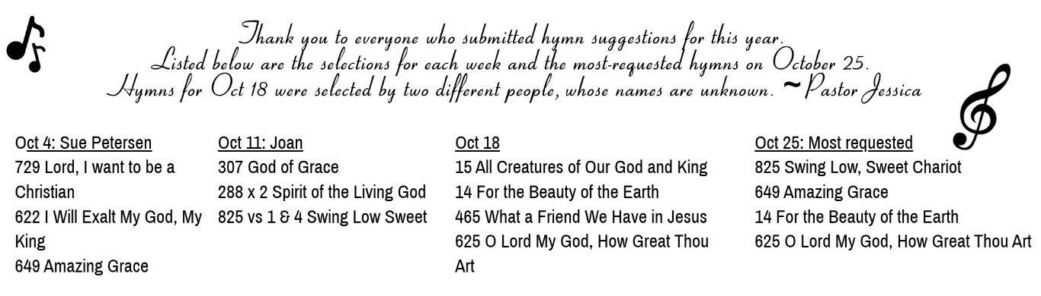

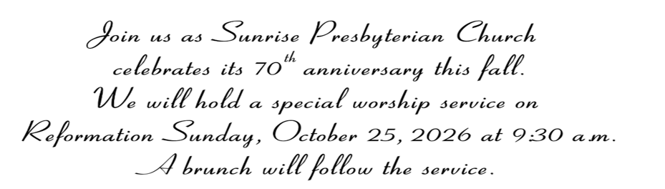

Beginning in October, you will see a change to the Fellowship Hosting Sign-Up sheet.
The 1st and 3rd Sundays of each month will be “Freezer Cookie” days.
The 2nd and 4th and occasional 5th Sundays of each month will be regular hosting days.

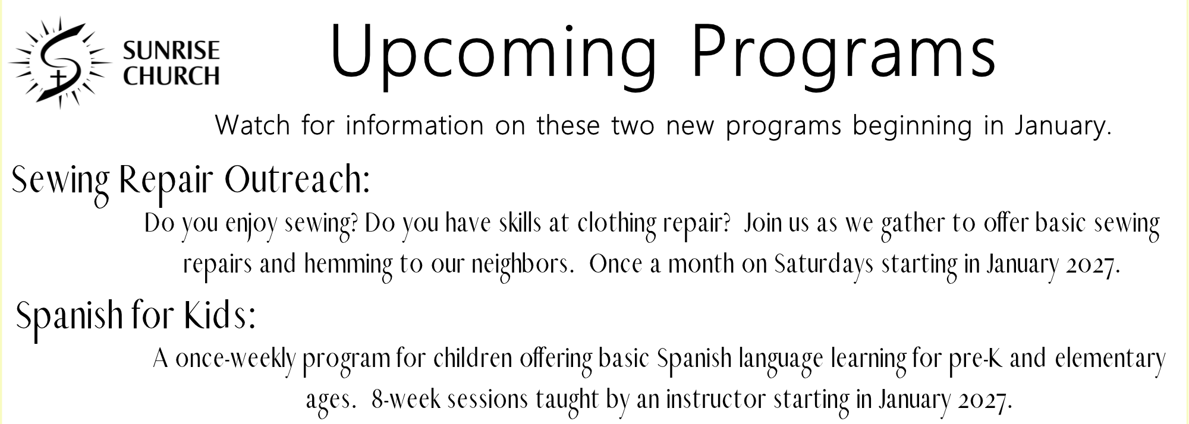
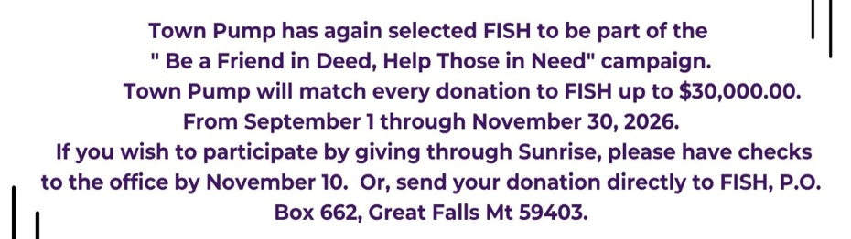

Child Protection Policy Update: The Session annually discusses and reviews the policies in place at Sunrise regarding conduct and child protection. This year, the session has updated the policy to include the following language.
“15. Church members, volunteers, staff, and guests shall use discretion in selecting age-appropriate language and content avoiding graphic descriptions of violence, war, war crimes, rape, murder, self-harm, drug use, or suicide when children or youth are present. This also applies to vulnerable adults. (A vulnerable adult is legally defined as a person aged 18 or older who is unable to protect or care for themselves due to a physical, mental, emotional, or developmental disability, sensory impairment, or the infirmities of aging.) If it is unclear what language should be used, individuals are encouraged to consult the minister or the Christian education committee.
16. If church members or participants witness acts of sexual harassment, racial discrimination, gender-based discrimination, or other violations of this policy, they shall immediately address these concerns, both verbally and in writing, to the church Session. Concerns should include the date, event/circumstances, and names of individuals involved and names of those who witnessed the incident.”
To see our full policies on conduct and child protection, visit our website where you can view the documents at any time.

Calendar of Events
October Deacons: Sandy Lambert & Sue Petersen
Oct 11 | Sun | 9:30 am | Worship w/ Communion & Children’s Sabbath
 |  | 10:30 am | Fellowship, no Sunday school
Oct 15 | Thu | 10:00 am | Bible Study
Oct 15-16 | Thu/Fri | All Day | No School for GFPS
Oct 16 | Fri | 11:00 am | Gail Bucko Memorial Service w/reception
Oct 18-20 | Sun/Tue | All Day | Pastor Jessica Gone; Glacier Presbytery
Oct 18 | Sun | 9:30 am | Worship w/ Rev. Steve Nelson
 |  | 10:30 am | Fellowship, no Sunday school
Oct 21 | Wed | 6:00 pm | Faith-Life, Outreach, Mission Meeting
Oct 25 | Sun | 9:30 am | Worship
 |  | 10:30 am | Fellowship w/ Brunch for 70th Anniversary
Oct 26/Nov 12 | Mon/Thu | All Day | Europe Trip Have a Blast 😊
Oct 28 | Wed | 10:00 am | Newsletter Folding
Oct 31 | Sat | All Day | Happy Halloween
November Deacons: Beth Hoseck & Pam Chigbrow
Nov 1-3 | Sun/Tue | All Day | Pastor Jessica gone/OPSF travel
Nov 1 | Sun | 9:30 am | Remembrance Service; Carol Stilli leading worship
 |  | 10:30 am | Fellowship
 |  | 10:45 am | Sunday School
 |  | 11:00 am | Deacons Meeting
Nov 4 | Wed | 6:00 pm | Worship Committee
Nov 5 | Thu | 10:00 am | Bible Study
Nov 5-8 | Thu/Sun | All Day | Pastor Jessica gone/OPSF travel
Nov 7 | Sat | All Day | Happy Birthday Kris Madison office admin
Nov 8 | Sun | 9:30 am | Worship; guest Minister Earl Terwilleger
 |  | 10:30 am | Fellowship
 |  | 10:45 am | Sunday School
 |  | 4:00 pm | Heritage Dinner
Nov 11-13 | Wed/Fri | All Day | Pastor Jessica gone/OPSF travel
Nov 11 | Wed | All Day | Happy Veterans Day
Nov 15 | Sun | 9:30 am | Worship w/ Communion
 |  | 10:30 am | Congregational Meeting then Fellowship
 |  | 10:45 am | Sunday School

Modeled after the Jewish practice of the youngest child asking four questions at the Passover Seder, this prayer allows children of the church to take an active role. Book of Common Worship, Westminster John Knox Press, c. 2018, p. 130+

